DATA MINING LAB ASSIGNMENT
Sections 3.1–3.6: Understanding, Measuring, Visualizing and Generalizing Data
Dataset: FPT Shop Product Catalog (fptshop.com.vn) — 1,100 products, 8 categories

1. Dataset Overview and Preprocessing
The dataset contains 1,100 product listings crawled from FPT Shop across eight categories: Laptop (337), Monitor (157), Refrigerator (131), Smartphone (129), Washing Machine (97), TV (94), Tablet (82), and Air Conditioner (73).
Original attributes: category, name, price_sale, price_original, discount, url, is_contact, brand.
Preprocessing:
• Brand normalization (Oppo→OPPO, ASUS→Asus, etc.); noisy tokens mapped to “Unknown”.
• Missing discount imputed from (price_original − price_sale)/price_original when possible; else 0.
• Missing price_original filled with price_sale. Derived: price_sale_m, category_en, brand_clean.
After cleaning, the three main numeric columns have zero missing values.

2. Section 3.1 – Data Classification
Objects: 1,100 product listings. Attributes: 8 original + derived variables.

Attribute Type Classification Table
Attribute | Type | Reason | Possible use
category / category_en | Nominal | Unordered categories | Grouping, IG, stratification
brand / brand_clean | Nominal | No inherent order | Market share analysis
name | Nominal | Textual identifier | Labeling
url | Nominal | Unique URL | Reference key
is_contact | Nominal (binary) | True/False flag | Filter
price_sale | Ratio | Absolute zero, ratios OK | Core numeric feature
price_original | Ratio | Same as price_sale | Discount calc.
discount | Ratio | Percentage, abs. zero | Promotion analysis
price_class (derived) | Ordinal | Low < Medium < High | Classification target
discount_level (derived) | Ordinal | Ordered tiers | Classification feature
Structure: mixed ratio + nominal attributes typical of e-commerce catalogs; prices strongly right-skewed.

3. Section 3.2 – Descriptive Statistics
Selected attributes: price_sale, price_original_filled, discount_filled.
Statistic | price_sale (VND) | price_original | discount (%)
Count | 1,100 | 1,100 | 1,100
Mean | 20,832,851 | 23,575,844 | 15.01
Median | 12,990,000 | 16,490,000 | 11.00
Std Dev | 23,576,910 | 25,077,156 | 13.83
Min / Max | 339k / 297.3M | 390k / 349M | 0 / 50
Q1 / Q3 | 5.99M / 27.99M | 7.97M / 31.74M | 3.6 / 25
IQR | 22.00M | 23.78M | 21.4
Skewness | 4.17 | 4.52 | 0.88

Interpretation
Mean ≫ Median for prices → strong right skew from luxury tail (flagships, high-end laptops). High Std and IQR confirm large variability. Discount is milder. Outliers are genuine premium products, not errors. Catalog is mid-range dominated with occasional deep discounts.

4. Section 3.3 – Data Visualization

4.1 Histogram of Sale Price
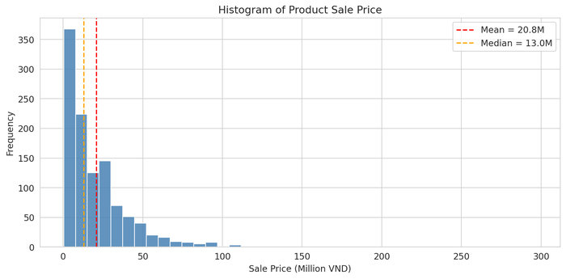
Right-skewed; majority of products under 20 million VND; long luxury tail.

4.2 Boxplot of Sale Price by Category
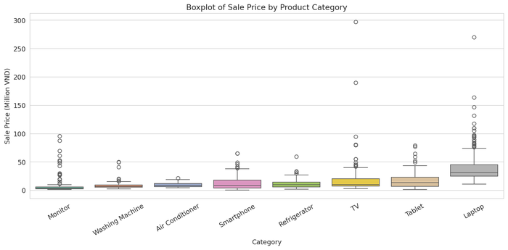
Laptops have highest median and many outliers; Monitors and budget appliances are cheapest. Category strongly drives price.

4.3 Quantile Plot of Sale Price
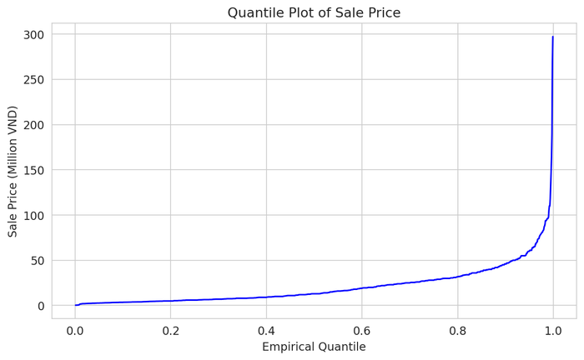
Steep upper quantiles confirm heavy right tail of luxury items.

4.4 Scatter: Sale Price vs Discount
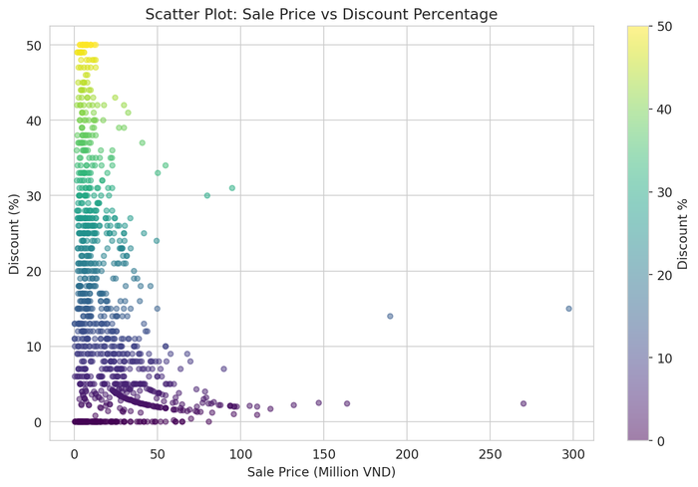
Moderate negative relationship: higher-priced items tend to have smaller % discounts. Deep discounts concentrate on mid/low-price products.

4.5 Multi-attribute: Count + Avg Price by Category
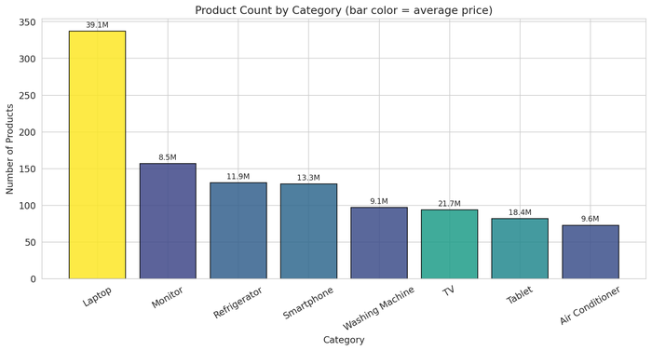
Laptop is largest and most expensive on average; Monitor has many listings but low average price. Color encodes average price.

5. Section 3.4 – Similarity and Distance
Twelve smartphones sampled (seed=42). Attributes price_sale and discount_filled Min-Max normalized to [0,1]. Euclidean distance used (suitable for continuous, equally-weighted normalized features).
3 most similar pairs:
Low-cost feature phones cluster tightly (e.g., Nubia V70 Max ↔ OPPO A5i / A6T, distances ≈ 0.01–0.02).
3 most different pairs:
Budget models vs. flagship foldables / high-end devices (e.g., Masstel Izi ↔ OPPO Find N6 or Samsung Z Fold8 Ultra).
Numerical distances agree with business intuition: similar price/discount profiles are close; luxury and entry-level devices are far apart.

6. Section 3.5 – Classification Measures

6.1 Discretization
price_class created by empirical tertiles (≈ equal frequency): Low ≤ 33rd pct (≈7.49M), Medium ≤ 66th pct (≈22.99M), High > 66th pct. Classes nearly balanced.

6.2 Entropy
H(price_class) ≈ 1.585 bits ≈ log₂(3). Target is maximally informative for a 3-class problem.

6.3 Information Gain
Attribute | Info. Gain
category_en | 0.514
brand_top | 0.448
discount_level | 0.158
Ranking: category > brand > discount_level.

6.4 Chi-square
price_class × category: χ²=702.96, p≈6e-141, dof=14 → highly significant.
price_class × brand_top: χ²=620.85, p≈1e-111, dof=30 → highly significant.

6.5 Correlation
r(price_sale, discount) = −0.324 (moderate negative). r(price_sale, price_original) = +0.990 (very strong). Correlation ≠ causation; deep discounts more common on lower-priced items.

7. Section 3.6 – Generalization and Summarization

Concept Hierarchies
1. Product → Category (Smartphone, Laptop, …).
2. Exact price → Price level: Budget (<5M) → Mid-range (5–15M) → Premium (15–30M) → Luxury (>30M).
3. Discount → Discount level: Low (≤10%) / Medium / High (>25%).

Data Cube & Attribute-Oriented Summary
Cube dimensions: category × price_level; measures: count, avg price, avg discount. Supports roll-up and drill-down.
Category | # | Avg Price | Med Price | Avg Disc | Top Brand
Laptop | 337 | 39.15M | 31.39M | 7.1% | Asus
Monitor | 157 | 8.46M | 3.69M | 17.0% | Gaming
Refrigerator | 131 | 11.88M | 10.09M | 24.5% | LG
Smartphone | 129 | 13.29M | 8.79M | 8.2% | Samsung
Washing Machine | 97 | 9.07M | 6.99M | 26.8% | —
TV | 94 | 21.65M | 10.29M | 23.4% | LG
Tablet | 82 | 18.38M | 13.49M | 8.2% | Samsung
Air Conditioner | 73 | 9.61M | 8.49M | 23.7% | Casper
Lost: exact model names & prices. Gained: compact managerial view, easy comparison, OLAP readiness.

8. Overall Findings and Key Insights
1. Multi-category catalog with strongly right-skewed prices.
2. Laptops dominate volume and average price; monitors are numerous but inexpensive.
3. Category is the strongest predictor of price class (highest IG + highly significant χ²).
4. Discount moderately negatively correlated with price.
5. Euclidean distance on normalized (price, discount) recovers intuitive smartphone similarity.
6. Hierarchies and data cube yield a clean, decision-ready summary.
Further work: ratings/reviews, brand-tier features, decision-tree on price_class.

9. Appendix
Source: fptshop_clean.csv (1,100 rows). Notebook: FPT_DataMining_Lab3_Analysis.ipynb. Libraries: pandas, numpy, scipy, scikit-learn, matplotlib, seaborn. Seed=42. Monetary unit: VND (M = million).

